NYSSLS Daily Lesson Plan
Instructional Unit: Weather and Climate |  |  |  |  | Period(s) of Unit: 5 |  |  | Date: n/a
Materials/Resources/Links: |  |  |  |  |  |  |  | Course: ES
Special Notes for Lesson: Concept Attainment with Interactive Lecture
Standards: HS-ESS2-8: Air Masses, Fronts, and Weather
HS-ESS2-5: Plan and conduct and investigation of properties of water and its effects on Earth materials and surface processes
HS-ESS3-3: Relationships of natural resources and biodiversity
HS-ESS3-2: Cost-Benefit Ratio Design Solutions
Science and Engineering Practices |  |  | Disciplinary Core Idea(s) |  |  |  | Cross Cutting Concepts
Performance Level
NYS Level 5 | NYS Level 4 |  |  | NYS Level 3 |  | NYS Level 2 |  | NYS Level 1
Collect and analyze global and regional weather data using tools, technologies, and/or models, to communicate in multiple formats how the movement and interactions of air masses result in changes in weather conditions. | Evaluate data and communicate information to explain how the movement and interactions of air masses result in changes in weather conditions. |  |  | Evaluate data and communicate information to identify the patterns of movement and/or interactions of air masses and/or the resulting changes in weather conditions. |  | Use data to identify the patterns of movement or the interactions of air masses and the resulting changes in weather conditions or to identify factors that drive the movement of air masses or from given weather conditions, identify evidence from maps that supports these conditions. |  | Use data and/or patterns of movement and interactions of air masses to identify the resulting changes in weather conditions or identify one factor that drives the movement of air masses or from those provided, use evidence from maps to account for weather conditions or given weather conditions, identify evidence found on maps that account for one of these conditions.
Clarification StatementExamples of evidence sources could include station models, surface weather maps, satellite images, radar, and accepted forecast models. Emphasis should focus on communicating how the uneven heating of Earth’s surface and prevailing global winds drive the movement of air masses and their corresponding circulation patterns, the interaction of different air masses at frontal boundaries, and resulting weather phenomena. |  |  |  |  |  | Assessment Boundary  Analysis is limited to surface weather maps and general weather patterns associated with high and low pressure systems.
Connection to Anchoring Phenomenon: How do winds and air masses change weather when there is an obstruction of a mountain chain that affects weather variables and creates a phenomena such as a windward and leeward side of a mountain that adversely affects a community of people and directly benefits others in the scientific phenomena.
Essential Question(s): Why does a tropical Island that has a geological structure as orogeny change the climate and social class of its habitants.
Instructional Strategies & Learning Tasks: Engage, Explore, Explain, Elaborate, Evaluate
Engage: Anchoring phenomenon, demonstration; observations of images, video clip or data… |  | Aerial photos of the Domenican Republic showing the grass lands vs Desert, showing two pictures of a biologist from Domenican Republic vs Haiti. Rain fall totals for the D.R. vs Haiti. Quick video clip of a typical day of Highs school student in the Domenican Republic vs Haiti.
Explore: Students investigate, experiment, hands-on activity…. |  | So after students see how the two different communities live and dwell under different circumstances and they see the landscape that has developed in the island the teacher will direct to a C.A.F. Why and how could this phenomena occur. Orogeny/mountains/latitude and longitude/climate vs weather. Windward vs leeward/Rain shadow Deforestation of land due to economics. The why, the how and when is this phenomena occurred in Haiti
Explain: Students share their observations and evidence to explain their understanding…possible whole group/class discussion… |  | Using a model of a windward/Leeward  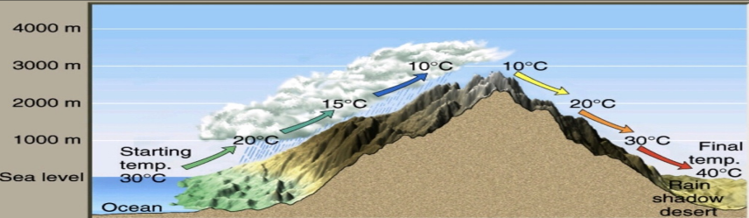  Students seeing and looking back to Living Environment and Ecosystems can see visually that water is necessary in order to have germination of grass and Primary consumers eating the autotrophs allows for energy to transfer from plant to animal and allows the ecosystem to thrive. This allows the forest to mature into a tropical rain forest that allows the maximum amount of chemical weathering and physical weathering to occur in this climate.
Elaborate: Students apply the science concepts they’ve just learned… |  | Once the students realize the topography of the island has a major impact on environment of the area, class discussion can lead us to finding out how these science concepts and apply to the capitalism of the island and how one side of the island has flourished and the other has become somewhat stagnant.
Evaluate (Formative Assessment): Student learning is evaluated. |  | In an ideal world is there a way that scientists and engineers could come together to solve the problem between the people of Haiti and the Dominican republic. Solutions to a problem that would make both sides happy and somewhat equal.

First I would have a worksheet on Page 12 outlining the Caribbean plate and how it shows convergent plates creates orogeny…. Then one for water cycle just to make sure vocabulary is on point. Then have students create a comparison between diagrams of water cycle and windward/leeward side… you could possibly go into the differences of low pressure belts and high pressure belts because of air sinking or rising…

